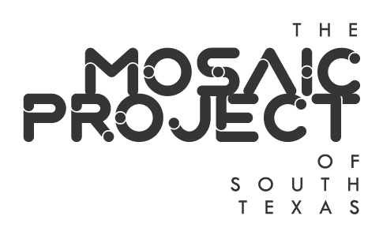
Mosaic Project of South Texas
Annual Meeting
Web & Teleconference
Corpus Christi, TX
Thursday, December 10, 2020
5:30 p.m.

- Call to Order/Establish Quorum – Tom Tagliabue, President
NAME | PRESENT | ABSENT
Tom Tagliabue, President
Bill Hoelscher, Treasurer
Liza Wisner, Secretary
Justin Colmenero
Crystal Garcia
Sofia Jimenez
Bill Richmond
Randy Stubbs
Jonathan Swindle
Dana Worsham

- Welcome Guests

- Adoption of Minutes from November 17, 2020 meeting – Liza Wisner, Secretary

- Treasurer’s Report – Bill Hoelscher, Treasurer

- Board member biographies and photos on PRIDECorpusChristi.com website

- Adoption of 2020 Annual Report – Tom Tagliabue, President

- Consideration and possible adoption of By-Laws– Tom Tagliabue, President
- Amend various sections of bylaws, include Title, Articles II (Purpose), III (Board of Directors) and IV (Financial Matters)
- Amend By-Laws, Article IX Code of Conduct, by adding Section 9.3 Social Media Policy (Secs. 9.3.1 through 9.3.6)

- Nomination and election of Officers for 2021
President
Treasurer
Secretary

- Proposed 2021 Meeting Plan
Currently meet the second Thursday of the month. Retain or change for 2021?

- Board Vacancy Nominations
Barton Bailey and Dr. Daniel Bartholomay both expressed interest in serving

- Planning for PRIDE 2021 and other activities
COVID-19 vaccine distribution and efficacy and impact on planning
June events indoors
October events outdoors
Seek volunteers to chair events
LGBT History Month
National Coming Out Day
World AIDS Day
Trans Day of Remembrance
Community Organization Events

- LGBTQIA+ Stakeholder Forum
CCLGBT, Coastal Bend PRIDE Center, Coastal Bend Trans Alliance, Texas Riviera Empire, LULAC Para Todos, Equality Texas Corpus Christi Steering Committee, Del Mar College Safe Space Club, Texas A&M University-Corpus Christi Cultural Alliance, Corpus Christi Police Department LGBT Liaison, affirming faith communities, sponsors, volunteers, vendors, friends, and allies of the LGBTQIA+ community.

- Next Board Meeting – Thursday, January 14, 2021, unless changed by Agenda Item IX

- Adjournment

