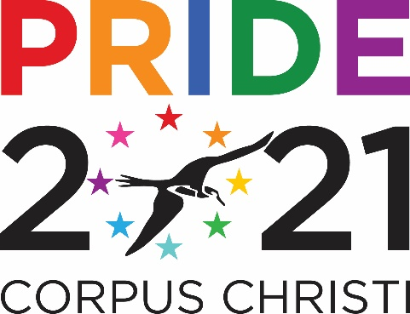
LGBTQIA+ ARTIST EXHIBITION
PRIDE MONTH – JUNE 1-30, 2021
La Palmera Gallery, Upper Level

Open call to all Lesbian, Gay, Bisexual, Transgender, Queer, Intersex, Asexual plus (LGBTQIA+) artists over the age of 18** who live in Corpus Christi or the Coastal Bend Region

- No entry fees.
- The work must be an original piece produced by the LGBTQIA+ artist making the submission.
- All media are eligible.
- Work must be submitted by artists who personally identify, or feel they have been defined by society, as a part of the LGBTQIA+ demographic.
- **If a participant is under the age of 18 we require that participants complete the legal guardian section in addition to the entry form.
- The goal of the exhibit is to celebrate the achievements of and gain recognition for LGBTQIA+ artists in the Coastal Bend.
- No specific subject matter is required. However, works inspired by or addressing life as an LGTBQIA+ individual are encouraged.
- Installation: content must fall within La Palmera’s Code of Conduct. (see on Page 4).
- Artists must submit by Friday, May 28, 2021 photographs of potential works to be exhibited to: info@pridecorpuschristi.com
If selected for exhibit, artists must submit a high-resolution photo of themselves and a biography written in Word format. Prefer bios to include information about the artist’s LGBQIA+ identification and how that influences their artistic creations.
- The Board of the Mosaic Project of South Texas/PRIDE Corpus Christi and exhibit curator will select the works to be displayed.
- Artists will be notified of acceptance of their selected works for exhibit as soon as possible after submissions close.
- All selected exhibit work shall be finished works and must be in suitable condition for exhibition. No wet paint. Artists must exhibit original works of art; we do not exhibit reproductions such as giclee/inkjet prints, high quality copies or offset lithograph prints.
- Maximum size for two-dimensional works is 48 X 48 inches. Maximum size for three-dimensional works is 24 X 24 X 24. Space limitations may preclude exhibition of multiple pieces.
- Artist agrees to display, install, pack, transport and provide for the return of his/her/their artwork at his/her/their own risk and expense. Arrangements may be made with the exhibit curator to install and display the selected work(s).
- Artist installation of their selected exhibited works will be on Monday, May 31, 2021. Exhibited art work must be removed on June 30, 2021.
- Three-dimensional works must be manageable by no more than two persons. Works must be ready to hang on a wall or if a base is needed, it must be provided by the artist or set on a table for display.
- Artists must submit his/her/their name and contact information and title of the exhibited work.
- Permission: Artist grants permission for La Palmera Mall and the Mosaic Project of South Texas/PRIDE Corpus Christi to reproduce his/her name, information describing his/ her/their work, representations of his/her/their work and any other information he/she/they provided for the purpose of display, promotion and publicity either now or in the future.
- The Artist gives La Palmera Mall and the Mosaic Project of South Texas/PRIDE Corpus Christi permission to use his/her/their work(s) of art in promotion materials (website, social media, print materials). Artists maintain copyright of all works selected for the exhibition. Artists are credited in promotional materials whenever possible.
- Release of Liability: La Palmera Mall and the Mosaic Project of South Texas/PRIDE Corpus Christi shall not be liable for any injury to Artist, their personnel, agents or employees or for any damage or loss of Artist’s work, equipment or other personal property arising out of the above Art Exhibitions, the mounting and/or any other activities involved in the preparation and/or presentation of the Art Exhibitions. Artist agrees to assume all risk of damage to or loss of his/her own art from whatever cause. Artist further agrees to release and to hold harmless La Palmera Mall and the Mosaic Project of South Texas/PRIDE Corpus Christi, its officers, directors, employees, volunteers and agents from any and all liabilities and damages to art work and/or persons as a result of any part of Artist’s participation in the exhibit.
- Indemnification: Artist shall indemnify, save and hold harmless La Palmera Mall and the Mosaic Project of South Texas/PRIDE Corpus Christi, its officers, directors, employees, volunteers and agents and the participating exhibition venues from any and all claims, demands, causes of action and judgments, losses, costs and expenses, including but not limited to reasonable attorney’s fees, arising due to the negligence of Artist, their employees, agents or other personnel hereunder, including but not limited to any representation, warranty, term and/or condition of this Agreement.
- Insurance: Artist shall be solely and exclusively responsible to insure properly and adequately their work and property. Works are not insured while on display. We recommend that you insure your work if you so choose.
- With this understanding, Artist releases La Palmera Mall and the Mosaic Project of South Texas/PRIDE Corpus Christi, its members, and its officers, from any liability for loss, theft, or damage to any piece of artwork or frame he/she submits.
ART SUBMISSION FORM
Info@pridecorpuschristi.com

ARTIST NAME |  |  | DATE
EMAIL ADDRESS |  |  | PHONE
MAILING ADDRESS
CITY, STATE |  |  | ZIP
WORK #1 | TITLE (Please Print/Type) | SIZE |  | Medium & Category (Canvas, Mixed/Fiber, Paper, Photography, Pottery, Sculpture, Other) | Price (if it is available for sale)  Otherwise note “Not Available For Sale”
WORK #2 | TITLE (Please Print/Type) | SIZE |  | Medium & Category (Canvas, Mixed/Fiber, Paper, Photography, Pottery, Sculpture, Other) | Price (if it is available for sale)  Otherwise note “Not Available For Sale”

If you are not above the age of 18 this event requires permission from a legal guardian, and contact information in case of any emergency.

Relationship to individual:

Emergency Contact information:

Signature: Printed name:
