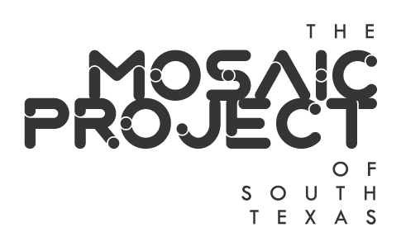
Mosaic Project of South Texas
Annual Meeting
La Palmera Community Room, Upper level
5488 South Padre Island Drive
Corpus Christi, TX
Thursday, December 9, 2021
6:00 p.m.

- Call to Order/Establish Quorum
NAME | PRESENT | ABSENT
Tom Tagliabue, President
Bill Hoelscher, Treasurer
Liza Wisner, Secretary
Justin Colmenero
Crystal Garcia
Sofia Jimenez
Bill Richmond
Randy Stubbs
Jonathan Swindle
Dana Worsham

- Adoption of Minutes from November 11 Board meeting and November 17, 2021 Board vote meeting – Liza Wisner, Secretary

- Treasurer’s Report – Bill Hoelscher, Treasurer

- Adoption of 2021 Annual Report – Tom Tagliabue, President

- Nomination and election of Officers for 2022
President
Treasurer
Secretary

- Proposed 2022 Meeting Plan -- Currently meet the second Thursday of the month. Retain or change for 2022?

- Planning for PRIDE 2022 and other activities
Corpus Christi Museum of Science and History would like to have the Parade along the same route as proposed for 2021 and the Block Party at the Museum on Saturday, October 8, 2022.
Indoor events in June for PRIDE Month?
Parade and Block Party for LGBT History Month in October?

- LGBTQIA+ Stakeholder Forum
CCLGBT, Coastal Bend PRIDE Center, Coastal Bend Trans Alliance, Texas Riviera Empire, LULAC Para Todos, Equality Texas Corpus Christi Steering Committee, Del Mar College Safe Space Club, Texas A&M University-Corpus Christi Cultural Alliance, Corpus Christi Police Department LGBT Liaison, affirming faith communities, sponsors, volunteers, vendors, friends, and allies of the LGBTQIA+ community.

- Next Board Meeting –

- Adjournment

